FILED
SEP 2019
KCDC - East Division
Bellevue
Court of Washington For |  | No. 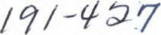  Petition for Order for Protection  (PTORPRT)
ZHANG Chunmei
Petitioner
Respondent
I. I am a victim of domestic violence committed by the respondent.
A member of my family or household is a victim of domestic violence committed by the respondent.
[ J I am a [ ] guardian [ ] guardian ad litem [ ] next friend of a minor who is 13 to 15 years of age and is a victim of domestic violence in a dating relationship with a person age 16 or older. The name of the minor victim is
This erson's identi •n information is rovided in ara ra h 5 below.
2. The victim lives in this county.
[ ] The victim left their residence because of abuse and this is the county of their new or former residence.
3. The victim's age is: Respondent's age is:
[ ] Under 16 [ | 16 or 17 18 or over [ ] Under 16 [ ] 16 or 17 18 or over
4. The victim and the respondent are:
Intimate Partners because they are:
[ ] current or former spouses or domestic partners [ ] parents of a child-in-common age 16 or older and are/were in a dating relationship, and are currently residing together or resided together in the past [ ] age 16 or older and are/were in a dating relationship, but have never resided together.
[ ] Family or household members because they are:
[ ] current or former adult cohabitants as roommates [ adult in-laws [ ] adults related by blood [ ] parent and child [ ] stepparent and stepchild [ ] grandparent and randchild.
- Identification of Minors (if applicable) [ No Minors involved.
Name  First, Middle Initial, Last | Age | Race | Sex | How Related to  Petitioner Res dent |  | Resides
Zhenxuan JIA ("Andy") | 12 | Asian | M | child | none | Petitioner
- Other court cases or other restraining, protection or no-contact orders involving me, the minors and the respondent:
Case Name
Case Number
Court/County
I Request an Order for Protection following a hearing that will:
¹ Restrain respondent from causing any physical harm, bodily injury, assault, including sexual assault, and from molesting, harassing, threatening, or stalking me the minors named in paragraph 5 above [ ] these minors only:
(If the court orders this relief, and you and the respondent are current or former spouses or domestic partners, parents of a child-in-common, age 16 or older and are/were in a dating relationship, and are currently residing together or resided together in the past, age 16 or older and are/were in a dating relationship, but have never resided together, the respondent will not be able to obtain or possess a firearm, other dangerous weapon, ammunition, or concealed pistol license for the duration of the order.)
² Restrain respondent from harassing, following, keeping under physical or electronic surveillance, cyberstalking as defined in RCW 9.61.260, and using telephonic, audiovisual, or other electronic means to monitor the actions, locations, or wire or electronic communication of me the minors named in paragraph 5 above [ ] only the minors listed below; [ ] members of the victim's household listed below [ ] the victim's adult children listed below:
³ Restrain respondent from coming near and from having any contact whatsoever, in person or through others, by phone, mail, or any means, directly or indirectly, except for mailing of court documents, with me the minors named in paragraph 5 above, subject to any court-ordered visitation [ ] these minors only, subject to any court-ordered visitation:
⁴ X Exclude respondent from [ ] our shared residence my residence my workplace my school the residence, day care, or school of the minors named in paragraph 5 above [ ] these minors only: [ ] Other:
You have a ri ht to kee ur residential address confidential.

5 [ I Direct-respondent to vacate our shared residence and restore it to me.
⁶ Prohibit respondent from knowingly coming within, or knowingly remaining within
100 ft (distance) of [ ] our shared residence my residence my workplace my school the day care or school of the minors named in paragraph 5 above. [ I these minors only: [ ] other:
7 Grant me possession of essential personal belongings, including the following:
my and my child's clothing items; my own original artworks, photo albums and portfolios, which are irreplaceable and irreproducible; jewelry; books; electronics; art supplies; musical instruments that belong to me and my child
⁸ [ ] Grant me use of the following vehicle:
Year, Make & Model License No.
] Other.
Protection involving a minor:
¹ 0 [ ] Subject to any court-ordered visitation, Grant me the care, custody and control of [ ] the minors named in paragraph 5 above [ ] these minors only:
11 Restrain respondent from interfering with my physical or legal custody of the minors named in paragraph 5 above [ ] these minors only:
¹² [ Restrain the respondent from removing from the state: [ ] the minors named in paragraph 5 above [ I these minors only:
Additional Requests:
¹³ X Direct the respondent to participate in appropriate treatment or counseling services.
¹⁴ Require the respondent to pay the fees and costs of this action.
¹⁵ Remain Effective longer than one year because respondent is likely to resume acts of domestic violence against me if the order expires in a year.
Protection involving pets.
¹6 [ I Grant me exclusive custody and control of the following pet(s) owned, possessed, leased, kept, or held by me, respondent, or a minor child residing with either me or the respondent. (Specify name of pet and type of animal.):
¹⁷ Prohibit respondent from interfering with my efforts to remove the pet(s) named above.
¹⁸ [ ] Prohibit respondent from knowingly coming within, or knowingly remaining within
(distance) of the following locations where the pet(s) are regularly found:
[ I petitioner's residence (You have a right to keep your residential address confidential.) Park [ I Other:
Protection from Firearms and Other Dangerous Weapons
¹⁹ Require the respondent to surrender all firearms, other dangerous weapons, and any concealed pistol licenses, and prohibit the respondent from accessing, obtaining, or possessing firearms, other dangerous weapons, or concealed pistol licenses.
Notice: If you are the respondent's intimate partner, after actual notice and an opportunity to be heard at the hearing, the court may be required to order the respondent to surrender firearms, other dangerous weapons, or concealed pistol licenses.
I want emergency temporary protection effective immediately, that lasts (up to 14 days) until the court hearing:
An emergency exists as described below. I request that a Temporary Order for
Protection granting the relief requested above in 1) through 12) be issued immediately, without prior notice to the respondent, to be effective until the hearing.
I also request temporary surrender all firearms, other dangerous weapons, and any concealed pistol licenses without notice to the other party because irreparable injury could result if an order is not issued until the hearing.
What irreparable harm would result if an order is not issued immediately without prior notice to the respondent?
Much of my property is still in his custody, some of which is of very high monetary and persona alue or is irreplaceable and irreproducible. Given that he has a history of arbitrarily destructing bjects in the household out of anger or frustration, as well as that he has intentionally denied e access to my belongings (medical equipment that I depend on necessary), it is very possible hat he could destruct or conceal m perty in retaliation of this legal action taken a ainst him.
Request for Special Assistance from Law Enforcement Agencies:
I request the court order the appropriate law enforcement agency to assist me in obtaining:
[ ] Possession of my residence. [ J Possession of the vehicle designated above. Possession of my essential personal belongings at [ ] the shared residence respondent's residence [ ] other location

[ ] Custody of [ ] the minors named in paragraph 5 above [ ] these minors only (if applicable):

[ I Other:

"Domestic violence" means physical harm, bodily injury, assault, including sexual assault, stalking, Or inflicting fear of imminent physical harm, bodily injury or assault between family or household members.
Statement: The respondent has committed acts of domestic violence as follows. (Describe specific acts of domestic violence and their beginning with the most recent @C!. You may want to include police responses.)
Describe the most recent violent act, fear or threat of violence, and why the temporary order should be entered today without notice to the respondent:
On September 8. 2019. in our exchange of text messages and emails as shown in Exhibit #1 (found at the end of this petition), Respondent called my friend and me his "enemies" — along with groundless accusations that I was somehow "threatening" him — and implied that I had yet to see what actions (the possibility of violence cannot be ruled out) he may take next.

On August 1 3, 2019. Respondent contacted me around midnight and insisted in an intimidating tone that J immediately go to his opartment; I complied. fearful of What could potentially hgppgn to my property (which was still in his custody). my child or me had I not done so. Upon my arrival, however, he began to demand that I must leave at once — a rather inexplicable and absurd change of mind, indeed — and proceeded to push me outside. Stunned and confused, I started retreating, only to find part of my hand and leg trapped in the doorway as he continued to aggressively force the door shut; as a result, still jammed in the door, my finger and foot sustained
Injunes, Inc u ng rmsess own In E |  | It #2.

On July 24.2019. Respondent and I — still residing together in his apartment at this point — engaged in a verbal confrontation. which was nevertheless escalated when he forcibly gripped onto and pulled my arm, resulting me falling on the ground. As a result, my arm sustained bruises shown in Exhibit #3.

Describe the past incidents where you experienced violence, where you were afraid of injury or where the respondent threatened to harm or kill you:

There have been numerous instances in which Respondent demanded that J perform sexual acts that I personally find anomalous and unpleasant. Such demands. though not accompanied bv direct physical violence, were essentially coercive in nature, for that he threatened to cut off financial support to me and my child had I not complied: while being well aware that I would not perform such sexual acts on my free will, but that I had no choice without compromising my — and more importantly, my child's — well-being.

Emotional abuse, unfortunately, has also been too commonplace throughout our relationship. Respondent had constantly and persistently called me "a monster," "useless," "stupid," "dumb" and "ignorant," among countless other degrading names, causing me to suffer substantial emotional and psychological pain, distress and torment.

Describe any violence or threats towards children:

Describe any stalking behavior by respondent, including use of telephonic, audiovisual or electronic means to harass or monitor:

Respondent has not ceased his attempts in contacting me through phone calls, text messages and emails, both directly and indirectly (through a friend of mine), despite my repeated request that he stop doing so.

Describe medical treatment you received and for what:

I did not receive any medical treatment for the iniuries sustained in the assaults described on Page 5 of this Petition due to my_ initial belief that medical attention did not appear necessary at the moment, and also to my concerns and uncertainties regarding whether my health insurance — which was under his name — is still active and usable.
Describe any threats of suicide or suicidal behavior by the respondent:

I have no knowledge of whether Respondent has previously made threats or attempts of suicide.

Does the respondent own or possess firearms? [ ] Yes [ ] No Unknown.
Does the respondent use firearms, weapons or objects to threaten or harm you? Please describe:
I have no knowledge of whether or not Respondent is in possession of any firearms or other dangerous weapons, nor do I have memory of other incidents in which Respondent threatened or harmed me with objects, aside from the assaults described on Page 5 of this Petition.

Has the respondent used, displayed, or threatened to use a firearm or other dangerous weapon in a felony? Please describe:
I have no knowledge of whether Respondent has previously committed a felony with a firearm or other dangerous weapon.

Is the respondent ineligible to possess a firearm under the provisions of RCW 9.41.040? Please describe:
I have no knowledge ofwhether Respondent is eligible to legally possess a firearm.

Does possession of a firearm or other dangerous weapon by the respondent present a serious and imminent threat to public health or safety, or to the health or safety of any individual?
Please describe:
Given his past history of violence, threats and intimidation, I believe that possession of a firearm or other dangerous weapon by Respondent does present a serious and imminent threat to my and my child's safety and well-being.

If you are requesting that the protection order lasts longer than one year, describe the reasons why:

Other:

(Continue on separate page if necessary.)
Check box if substance abuse is involved: [ ] alcohol [ ] drugs [ ] other
[ ] Personal service cannot be made upon respondent within the state of Washington.
I declare under penalty of perjury under the laws of the state of Washington that the foregoing is true and correct.
Dated:
You have a right to keep your residential address confidential. If you have one, ple an address, other than your residence, where you may receive legal documents:
Chunmei Zhang c/o Chengtao Hua, 5209 15th Ave NE Apt 302, Seattle WA 98105

Exhibit #1
Sprint
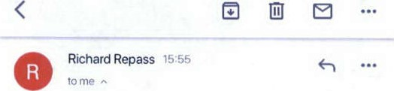
From Richard Repass rrepass@gmailcom
To mei Zhang summer903907@grnail.com
Date sep 8, 2019, 1555
Standard encryption (TLS)
6
Learn more
If you take me to court, I will fight with all my life to not pay you a cent, and for you to pay legal fees. I will fight the rest of my life. You will lose, because
have on lawyers if I have to. You are now the enemy of me and my children because you threatened me and your friend said the same.

Act like this only make things uglier
You are like magic—you turn love into disgust
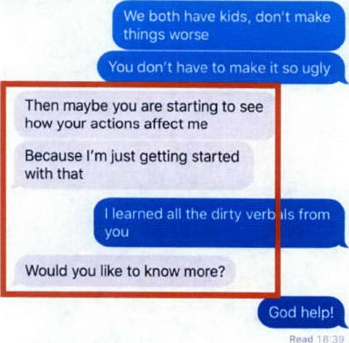
 o • 0000 e o
Exhibit #2
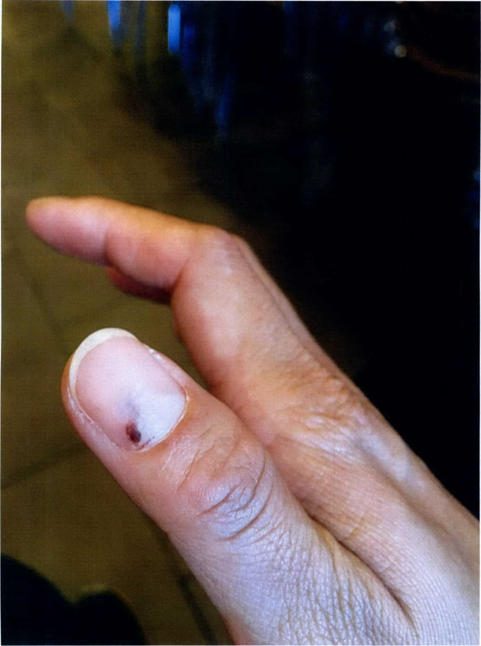
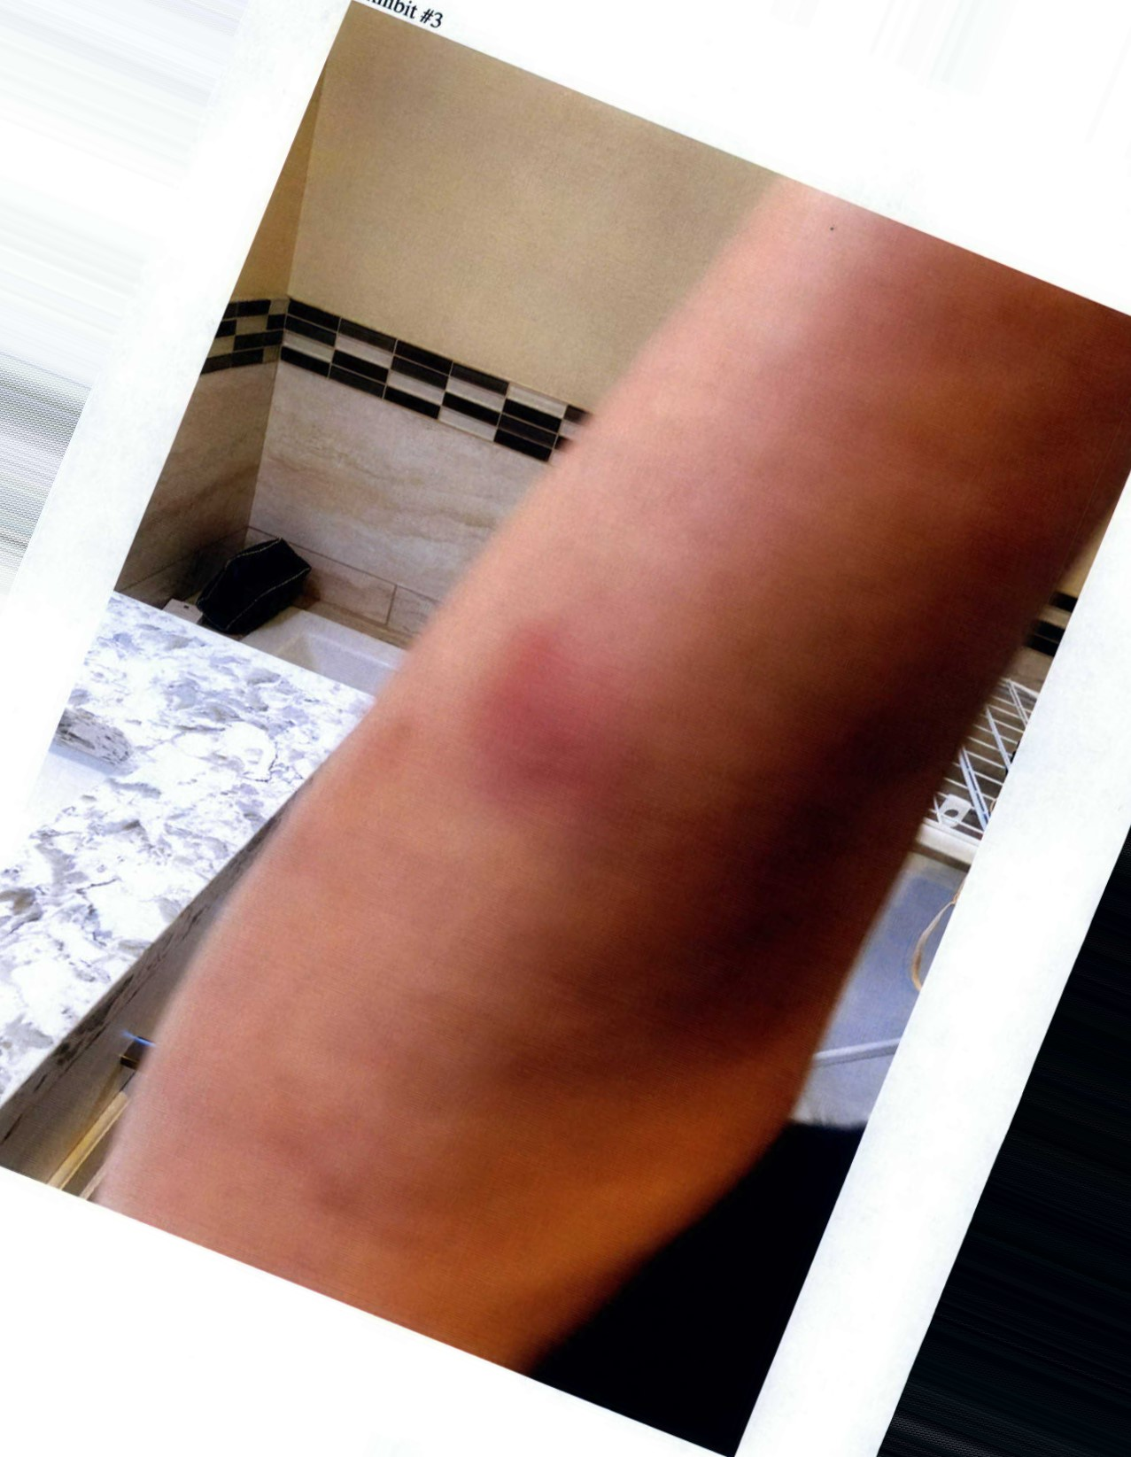
exhibit

